Abstract
Analysing security-related events is a crucial task in today’s computer and network surveillance in order to detect and analyse malicious intrusions. However, detecting single events are often not sufficient to reliably identify hacking attacks. Temporal or causal related chains of events are more sophisticated metrics for detecting intrusions.[1]
Team Uranus’ CEP-based SIEM system, version 1.0, is a prototypical event processing project with the purpose of monitoring and detecting simple attack scenarios to a computing system. This system is able to monitor a web server for login and restricted resource access events, detect port scans based on TCP packets, and monitor the CPU and memory usage of the machine. In addition, the system is able to display alerts with their priorities to the users via a dashboard, with which users can also configure their alert priorities and system configurations.
Keywords : SIEM, CEP, port scan, dashboard
Introduction
Background
As modern computer networks and computing systems deal with a greater volume of invaluable information and data, they have been becoming ideal targets for attackers with malicious intent. For example, attackers can conduct a brute force attack on password-protected web servers to gain access to a user account and thus the resources that user has access to. They can also scan available ports on the corresponding system or network, known as a port scan, so as to gain knowledge of running services and security flaws of the network, which is used as a precursor to subsequent attacks. In addition, they can run malicious programmes which withhold computer resources and deny other, more essential tasks of accessing to them.
Therefore, IT security has become one of the most heavily emphasised aspects with respect to these systems. One of the methods in which security systems can surveil systems is by analysing security-related events. However, detecting single events is in most of the case insufficient to reliably identify attack scenarios. Security systems must also be able to detect temporal or causal related chains of events in order to identify attacks. Nowadays, a SIEM (Security Information and Event Management) system is the state-of-the-art solution to acquire, detect, alert and analyse security-related events on a large amount of IT devices.
Project requirements
In this project, we will design and implement a prototypical SIEM system to monitor and report several potential attacks based on the CEP (Complex Event Processing) paradigm written in Java. More specifically, the system should be able to :
- Monitor a web server and detect consecutive unsuccessful login attempts to alert users of potential brute force attacks as well as detect illegal attempts of accessing forbidden resources of the web server.
- Monitor the network connections of hosts and alert users of when a port scan is detected. Furthermore, it should also detect failed connections on a closed port, which may hinted at a software misconfiguration, causing the usage of a wrong port number.
- Monitor the resource usage of the machine and alert users whenever the CPU and memory usage exceeds a certain threshold.
- Display all alerts to the users by means of a dashboard. In addition, users should be able to configure the system configurations and alert priorities via that dashboard.
Foundations
SIEM system
SIEM or Security Information and Event Management is defined as a complex set of technologies brought together to provide a holistic view into a technical infrastructure.
At its core, a SIEM provides :
- Event and Log collection : This may come in many forms, especially with in-house applications.
- Layered Centric Views or Heterogeneous : This is usually in the form of dashboards or “views,” referred to as a bird’s-eye view.
- Normalization: a two-part function. This includes translating computerized jargon to readable data to be displayed, and mapping data to user- or vendor-defined classifications/characterizations. This is sometimes referred to as “field mapping.”
- Correlation: This essentially gives the data context and forms relationships based on rules, architecture, and alerts. This should be either historical or real-time.
- Adaptability (Scalable): This dumbs down to being able to speak the language regardless of source vendor, format, type, change or compliance requirement.
- Reporting and Alerting: This may be used to not only show value to executives but also provide automated verification of continuous monitoring, trends, and auditing. Some would argue that the auditing aspect is an essential function but the SIEM alone does nothing – like a retired general with no troops or a SQL instance with no tables or data.
- Log Management: Allowing the capability for storing event and logs into a central location, while also allowing the application of compliance storage or retention requirements.
CEP
Complex event processing (CEP) refers to resources that collect different kinds of data from different parts of an IT system, or other sources, to look for meaningful results that can be reported to decision makers. In many cases, a complex event processing system is an organizational tool that helps to aggregate a lot of different information about an enterprise in order to assist in high-level planning.
Within a CEP system, event sources (event producers) can be any kind of entity which can be connected to a computer. The event sources produce “raw events”, which are occurrences in the application domain which are of interest. Then the raw events are consumed by a CEP engine in form of a continuous event stream. The CEP engine analyses and processes events by extraction, aggregation, filtering and pattern detection, generating higher-order, or meaningful, events as a result.
Esper
The Esper compiler and runtime have been developed to address the requirements of applications that analyze and react to events. Some typical examples of applications are:
- Business process management and automation (process monitoring, BAM, reporting exceptions)
- Finance (algorithmic trading, fraud detection, risk management)
- Network and application monitoring (intrusion detection, SLA monitoring)
- Sensor network applications (RFID reading, scheduling and control of fabrication lines, air traffic)
What these applications have in common is the requirement to process events (or messages) in real-time or near real-time. This is sometimes referred to as complex event processing (CEP) and event series analysis. Key considerations for these types of applications are throughput, latency and the complexity of the logic required.
- High throughput - applications that process large volumes of messages (between 1,000 to 100k messages per second)
- Low latency - applications that react in real-time to conditions that occur (from a few milliseconds to a few seconds)
- Complex computations - applications that detect patterns among events (event correlation), filter events, aggregate time or length windows of events, join event series, trigger based on absence of events etc.
The EPL compiler and runtime were designed to make it easier to build and extend CEP applications.
EPL
The Esper language is the Event Processing Language (EPL) designed for Complex Event Processing and Streaming Analytics.
EPL is organized into modules. Modules are compiled into byte code by the compiler. We use the term module for an EPL source code unit.
A module consists of statements. Statements are the declarative code for performing event and time analysis. Most statements are in the form of "select ... from ...". We use the term statement for each unit of declarative code that makes up a module.
Your application receives output from statements via callback or by iterating current results of a statement.
A statement can declare an EPL-object such as listed below:
- Event types define stream type information and are added using create schema or by configuration.
- Variables are free-form value holders and are added using create variable or by configuration.
- Named windows are sharable named data windows and are added using create window.
- Tables are sharable organized rows with columns that are simple, aggregation and complex types, and are added using create table.
- Contexts define analysis lifecycle and are added using create context.
- Expressions and Scripts are reusable expressions and are added using create expression.
- Indexes organize named window events and table rows for fast lookup and are added using create index.
Use access modifiers such as private, protected and public to control access to EPL-objects.
A module can optionally have a module name. The module name has a similar use as the package name or namespace name in a programming language. A module name is used to organize EPL objects and to avoid name conflicts.
When deploying a compiled module the runtime assigns a deployment id to the deployment. The deployment id uniquely identifies a given deployment of a compiled module. A compiled module can be parameterized and deployed multiple times.
A statement always has a statement name. The statement name identifies a statement within a deployed module and is unique within a deployment. The combination of deployment id and statement name uniquely identifies a statement within a runtime.
EPL is type-safe in that EPL does not allow performing an operation on an object that is invalid for that object.
System architecture
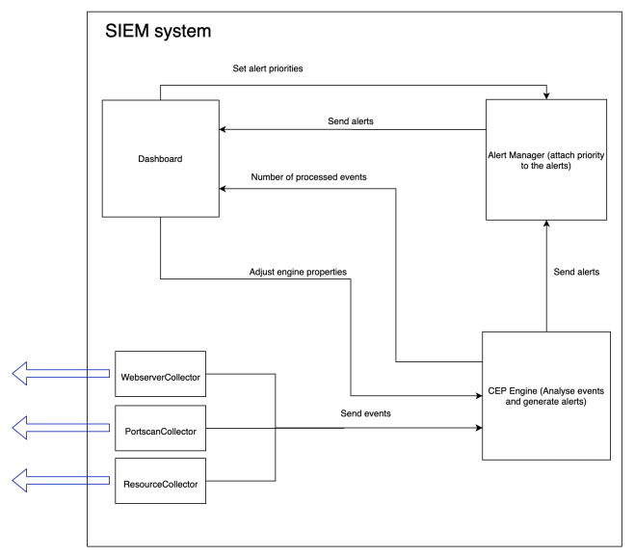
The SIEM system developed for this project consists of four component : the collectors, the CEP engine, the alert manager, and the dashboard.
- The collectors extract the raw events from the data sources and send them to the CEP engine. There are three collectors within the systems, each corresponding to a task of the project. The web server collector reads the web server log file for HTTP log entries using the Java buffered reader and sends them to the CEP engine as AccessLogEvent objects. The port scan collector captures TCP packets from the network using the external library Pcap4J and sends them to the CEP engine as TcpPacketEvent objects. The resource collector uses the libraries OperatingSystemMXBean and OSHI to extract information about the current CPU and memory usage of the machine and sends the results to the CEP engine as ResourceMonitorEvent objects.
- The CEP engine receives the raw events from the collectors, processes them using pre-defined EPL statements and generates alerts. It also receives the properties settings from the dashboard and modifies the EPL statements accordingly. The CEP engine is also able to count the number of each event and sends the results to the dashboard for display.
- The alert manager manages all alerts in the system. It receives the alert parameters from the CEP engine and modifies the alert attributes e.g. timestamp, message. It also receives the alert priorities settings from the dashboard and modifies the alert priorities accordingly. Then it sends the alerts to the dashboard.
- The dashboard serves as the interface between the system and the users. The dashboard displays the alerts with their timestamps and priorities as well as the event count to the users. It also records alert priorities and engine properties settings and send them to the alert manager and the CEP engine, respectively.
An in-depth system description will be discussed in chapter 4, System Description.
Web server module
In the web server module, the event hierarchy is illustrated in the figure below.
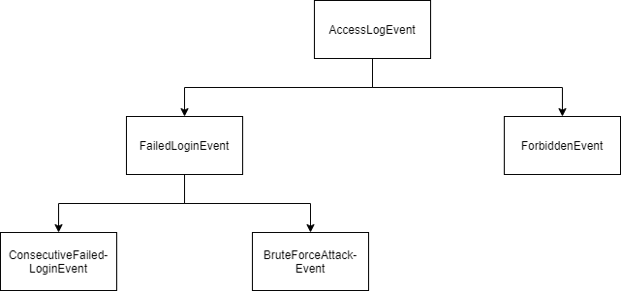
The AccessLogEvent event is the raw event sent by the collector. A FailedLoginEvent event is raised when a user logs in unsuccessfully. A ForbiddenEvent event is raised when a user attempts to access a resource which he or she is not allowed to access. A ConsecutiveFailedLoginEvent event is raised when a user logs in unsuccessfully for multiple times consecutively within a specified period of time. A BruteForceAttackEvent event is also raised when a user logs in unsuccessfully for multiple times consecutively within a specified period of time, but its attempt threshold is generally greater than that of a ConsecutiveFailedLoginEvent event
In the activate() method of the class WebserverModule, all raw access log events are first selected by the CEP engine for counting purpose. The corresponding EPL statement is :
select * from AccessLogEvent;
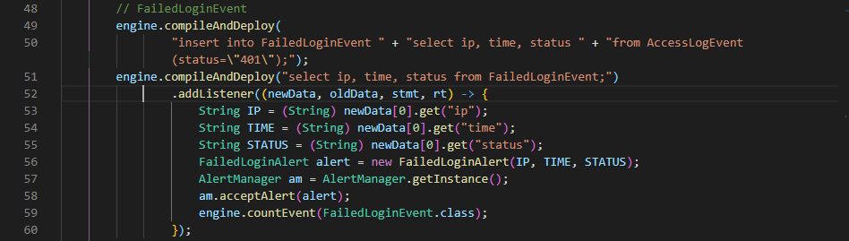
To create a new failed login event, defined as events where the user authenticates himself / herself unsuccessfully, the following EPL statement is called :
insert into FailedLoginEvent select ip, time, status from AccessLogEvent(status="401");
This statement looks for AccessLogEvent events with the status value of “401” (the HTTP status code for unauthorized access), gets their IP, timestamp and status code to assign them to the attributes of a new FailedLoginEvent.
To select all FailedLoginEvent events, the following EPL statement is called :
select ip, time, status from FailedLoginEvent;
A listener is attached to this EPL statement. In this listener, the IP address, timestamp and status code is used to create a new FailedLoginAlert and the event counter counts this FailedLoginEvent event.
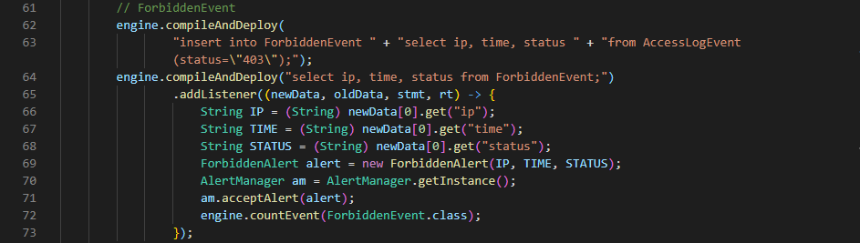
To create a new ForbiddenEvent, a similar approach is used. The only difference is that the EPL now searches for AccessLogEvent events with the status value of “403” (the HTTP status code for forbidden resource access).
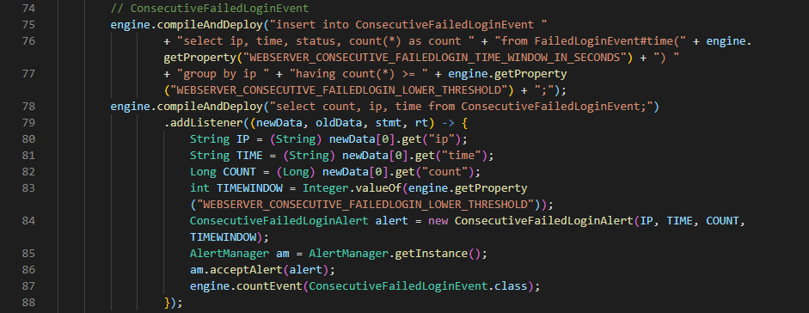
To create a new ConsecutiveFailedLoginEvent event, the following EPL statement is called :
"insert into ConsecutiveFailedLoginEvent " +
"select ip, time, status, count(*) as count " +
"from FailedLoginEvent#time(" + engine.getProperty("WEBSERVER_CONSECUTIVE_FAILEDLOGIN_TIME_WINDOW_IN_SECONDS") + ") " +
"group by ip " +
"having count(*) >= " + engine.getProperty("WEBSERVER_CONSECUTIVE_FAILEDLOGIN_LOWER_THRESHOLD") + ";"
This statement will fire if it finds “WEBSERVER_CONSECUTIVE_FAILEDLOGIN_ LOWER_THRESHOLD” or more FailedLoginEvent events from the same IP address within a time window of “WEBSERVER_CONSECUTIVE_FAILEDLOGIN_TIME_WINDOW_IN_ SECONDS” seconds.
Then the EPL statement “select count, ip, time from ConsecutiveFailed- LoginEvent;” is called to select all ConsecutiveFailedLoginEvent events. A listener is attached to this statement, in which the IP address and timestamp of the event, the number of failed login attempts by this attempt and the current time window are used to create a new alert of type ConsecutiveFailedLoginAlert, and the event counter increments the counter for this type of event.
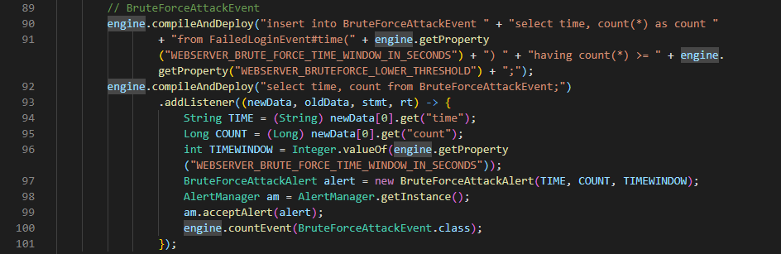
To create a new BruteForceAttackEvent and thus a new BruteForceAttack- Alert, a similar approach to the ConsecutiveFailedLoginEvent is used. The only different variables are the minimum number of failed login attempts that constitute the event (defined by the property “WEBSERVER_BRUTEFORCE_LOWER_THRESHOLD”) and the considered time window (defined by the property “WEBSERVER_BRUTE_FORCE_ TIME_WINDOW_IN_SECONDS”).
Port scan module
In the port scan module, the event hierarchy is illustrated in the figure below.
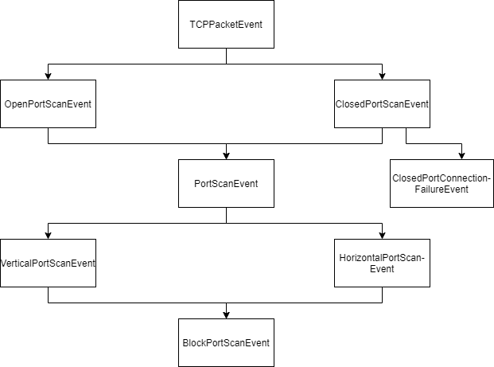
The TCPPacketEvent is the raw event sent by the collector. A ClosedPortScan- Event event is raised when a client sends a TCP packet with the SYN flag set to true to the server and then the server sends a TCP packet with the ACK and RST flags set to true back to the client. An OpenPortScanEvent is raised when a client conducts a three-way handshake with the server and then the server sends a TCP packet with the RST flag set to true back to the client (see figure below). PortScanEvent events are comprised of both ClosedPortScanEvent events and OpenPortScanEvent events and it is raised whenever any of the two port scan events is raised. A ClosedPort- ConnectionFailureEvent event is raised when a ClosedPortConnection- FailureEvent event is raised, however a time window is applied so only a limited number of events of type ClosedPortConnectionFailureEvent are stored. A VerticalPortScanEvent event is raised when the CEP engine detects a potential vertical port scan, in which a client is scanning a host on multiple ports. A HorizontalPortScanEvent event is raised when the CEP engine detects a potential horizontal port scan, in which a client is scanning multiple hosts on one port. A BlockPortScanEvent event is raised when the CEP engine detects a potential block port scan, in which a horizontal and a vertical port scan are conducted in combination.
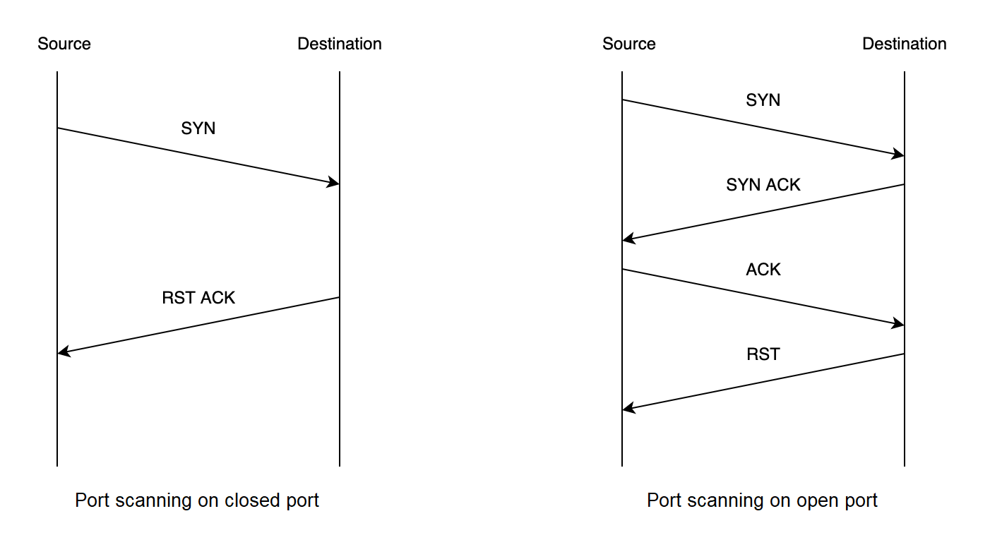
In the activate() method of the class PortscanModule, all raw events are first selected by the CEP engine for counting purpose. The corresponding EPL statement is :
select * from TcpPacketEvent;
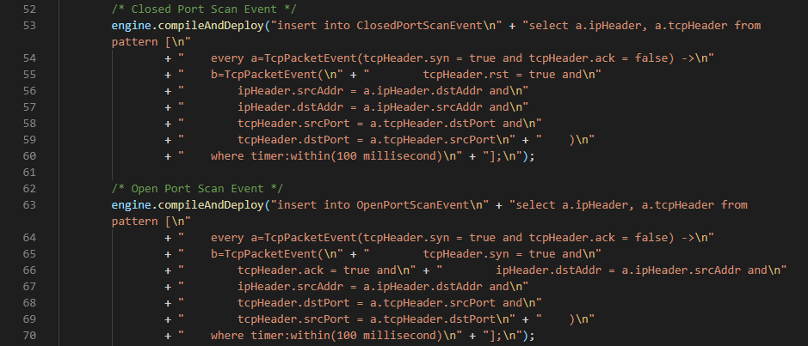
The two EPL statements illustrated in the figure above search for raw events which match the definition of a closed port scan event and an open port scan event defined above and extract their IP headers and TCP headers, from which information such as the source address and port and destination address and port is assigned to the new events.
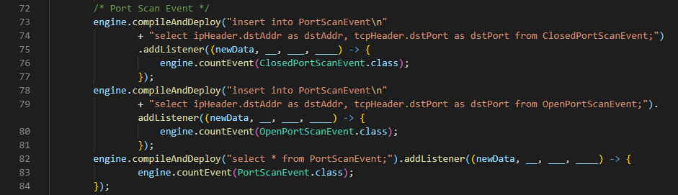
After that, the EPL statements at line 73 and line 78 select the destination address and port of each port scan event and inserted them into a new PortScanEvent event. In addition, the event counter increments its count of ClosedPortScanEvent, OpenPortScanEvent, and PortScanEvent events.
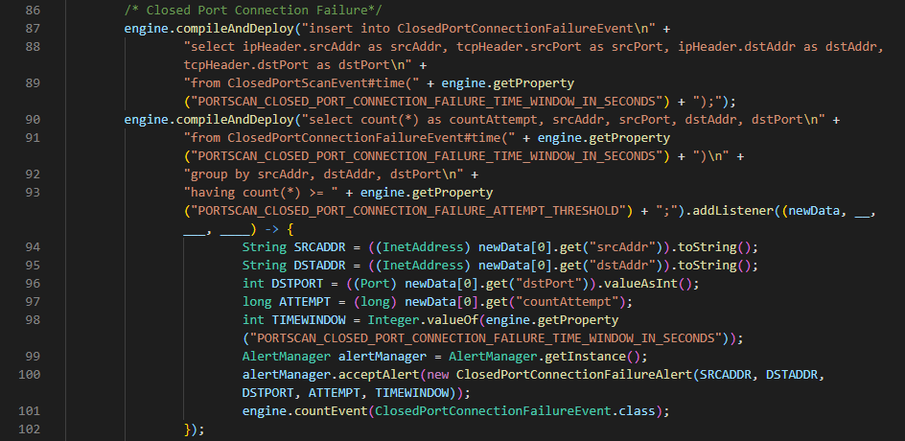
To search for multiple failed closed port connection attempts, the CEP engine first selects the source address and port and destination address and port of all ClosedPortScanEvent events within a time window of “PORTSCAN_CLOSED_PORT_ CONNECTION_FAILURE_TIME_WINDOW_IN_SECONDS” seconds and inserted them into a new ClosedPortConnectionFailureEvent event. Then the EPL statement at line 90 searches for instances of more than a defined threshold number of ClosedPortConnectionFailureEvent events which have the similar source address, destination address and destination port within the above time window. A listener is attached to this EPL statement. It takes the source address, destination address, destination port, current number of connection attempts and the current time window (in seconds) of the connection attempt to create a new alert of type ClosedPortConnectionFailureAlert. Finally, the event counter increments its count of ClosedPortConnectionFailureEvent events.
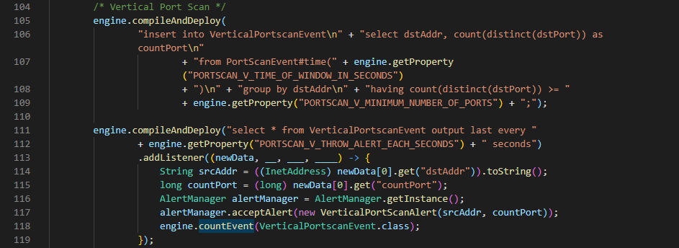
To detect a vertical port scan, the EPL statement at line 105 searches for instances of a greater number of PortScanEvent events that have the same destination address but different destination port numbers than a defined threshold within a time window, which indicate a vertical port scan. It selects the destination address and the number of ports scanned on that destination address and inserts them into a new VerticalPortscanEvent event. Then the EPL statement at line 111 selects the VerticalPortscanEvent events to create a new alert. However, the keyword “output last” is used in order to prevent the creation of too many alert objects when the number of ports scanned greatly exceeds the defined threshold. This keyword defines a time period between two events to be output. A listener is attached to this EPL statement. It takes the destination address and the number of ports scanned to create a new alert of type VerticalPortScanAlert. Finally, the event counter increments its count of VerticalPortScanEvent events.
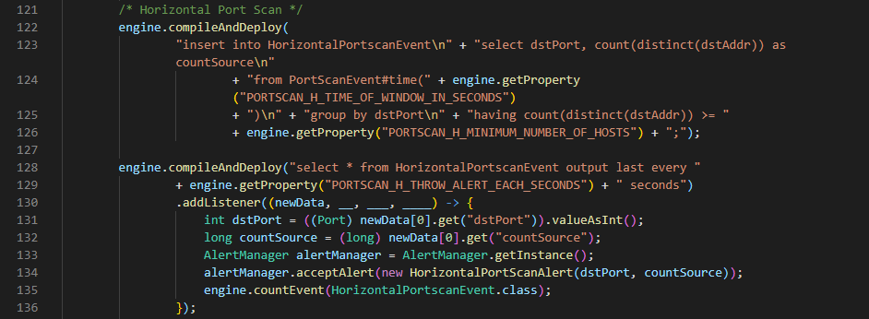
To detect a horizontal port scan, the EPL statement at line 122 searches for instances of a greater number of PortScanEvent events which have the same destination port number but different destination addresses than a defined threshold within a time window, which indicate a horizontal port scan. It selects the destination port number and the count of destination addresses whose port is scanned and inserts them into a new HorizontalPortscanEvent event. Then the EPL statement at line 128 selects the HorizontalPortscanEvent events to create an alert, also using the “output last” keyword to limit the number of alerts created. A listener is attached to this EPL statement. It takes the destination port number and count of hosts scanned to create a new alert of type HorizontalPortScanAlert. Finally, the event counter increments its count of HorizontalPortScanEvent events.
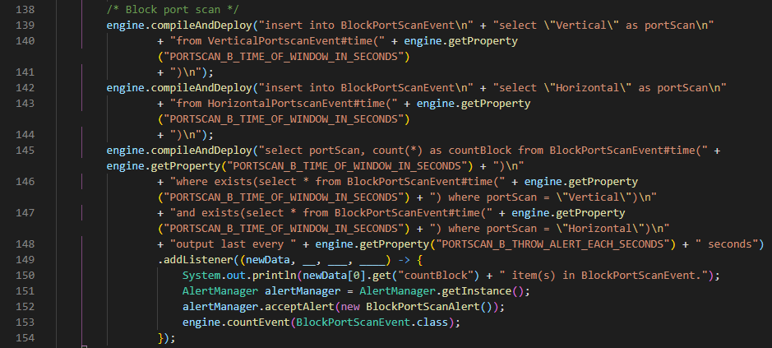
To detect a block port scan, first the EPL statements at line 139 and line 142 create a new BlockPortScanEvent event whenever a new VerticalPortscanEvent or HorizontalPortscanEvent event is created within a time window. Each Block- PortScanEvent has only one attribute portScan, which has the value “Vertical” if the event is a vertical port scan event or “Horizontal” if the event is a horizontal port scan event. Then the EPL statement at line 145 checks whether there are both vertical and horizontal port scan events in the BlockPortScanEvent events within the time window. If that is true, it will create a new alert of type BlockPortScanAlert. Finally the event counter increments its count of BlockPortScanEvent events.
Resource module
In the resource module, the event hierarchy is illustrated in the figure below.
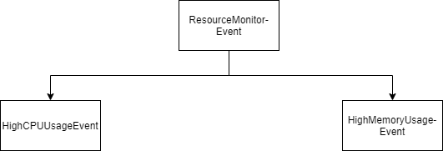
The ResourceMonitorEvent is the raw event sent by the collector. A HighCPU- UsageEvent event is raised when the CEP engine detects that the CPU usage (in %) exceeds a defined threshold within a defined time window. A HighMemoryUsageEvent event is raised when the CEP engine detects that the memory usage (in %) exceeds a defined threshold within a defined time window.
In the activate() method of the class ResourceModule, all raw events are first selected by the CEP engine for counting purpose. The corresponding EPL statement is :
select * from ResourceMonitorEvent;
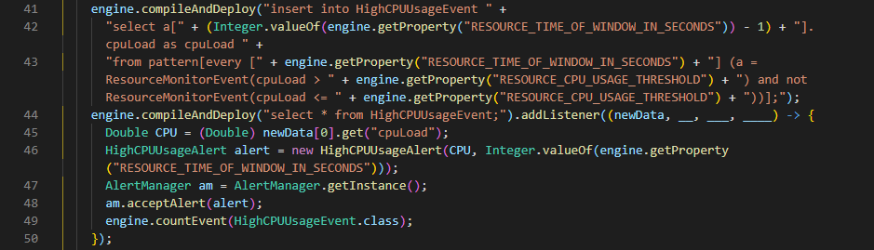
To create a new HighCPUUsageEvent, the EPL statement at line 41 searches for instances in the raw events where CPU usage percentage values are consistently greater than the defined threshold within a defined time window. Since a new raw event is generated every second, the statement checks whether the condition is satisfied for the number of times which is equal to the number of seconds in the time window. For example, if the time window is set to 5 seconds, the statement will check whether there are 5 consecutive raw events where the CPU usage is greater than the threshold. Then the statement selects CPU usage value of the latest event to add to the new HighCPUUsageEvent event. After that, the EPL statement at line 44 selects all HighCPUUsageEvent events. A listener is attached to this statement. It takes the latest CPU usage value and the current time window as parameters to create a new alert of type HighCPUUsageAlert. Finally the event counter increments its count of HighCPUUsageEvent events.
To create a new HighMemoryUsageEvent, the EPL statements work in a similar fashion.
